1. Write a class that will represent a LeggedMammal. Consider the number of legs, kind of fur, presence of tail.

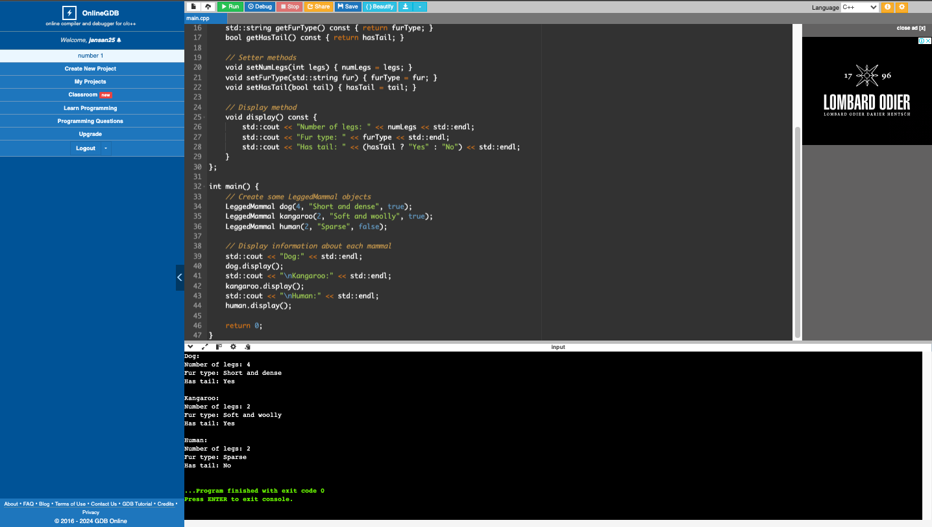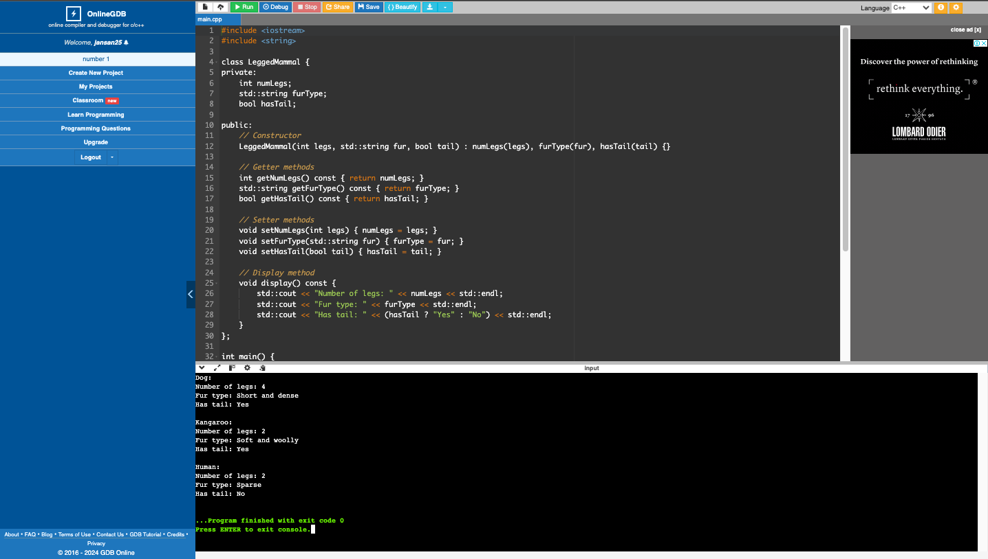

1. Write a class that will represent a Person. Consider the name, address, gender, age and occupation.

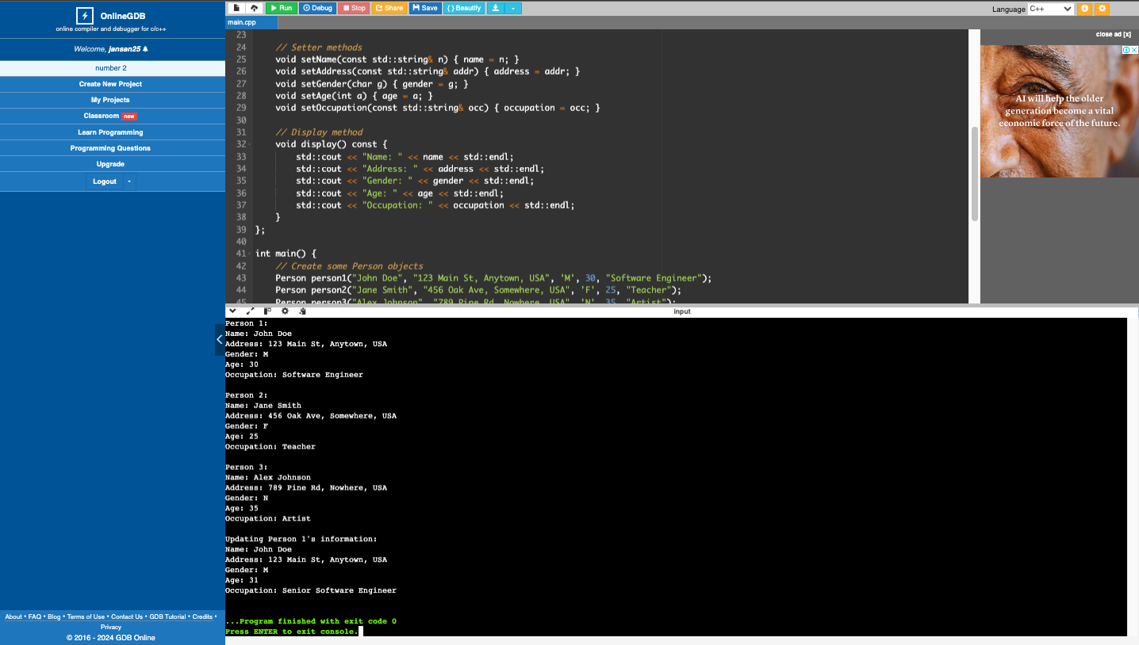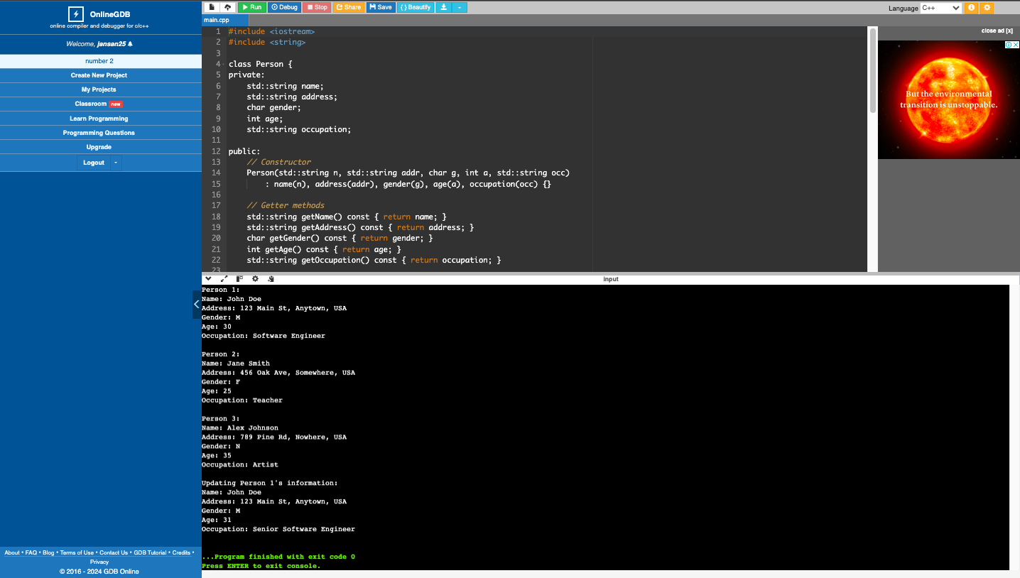

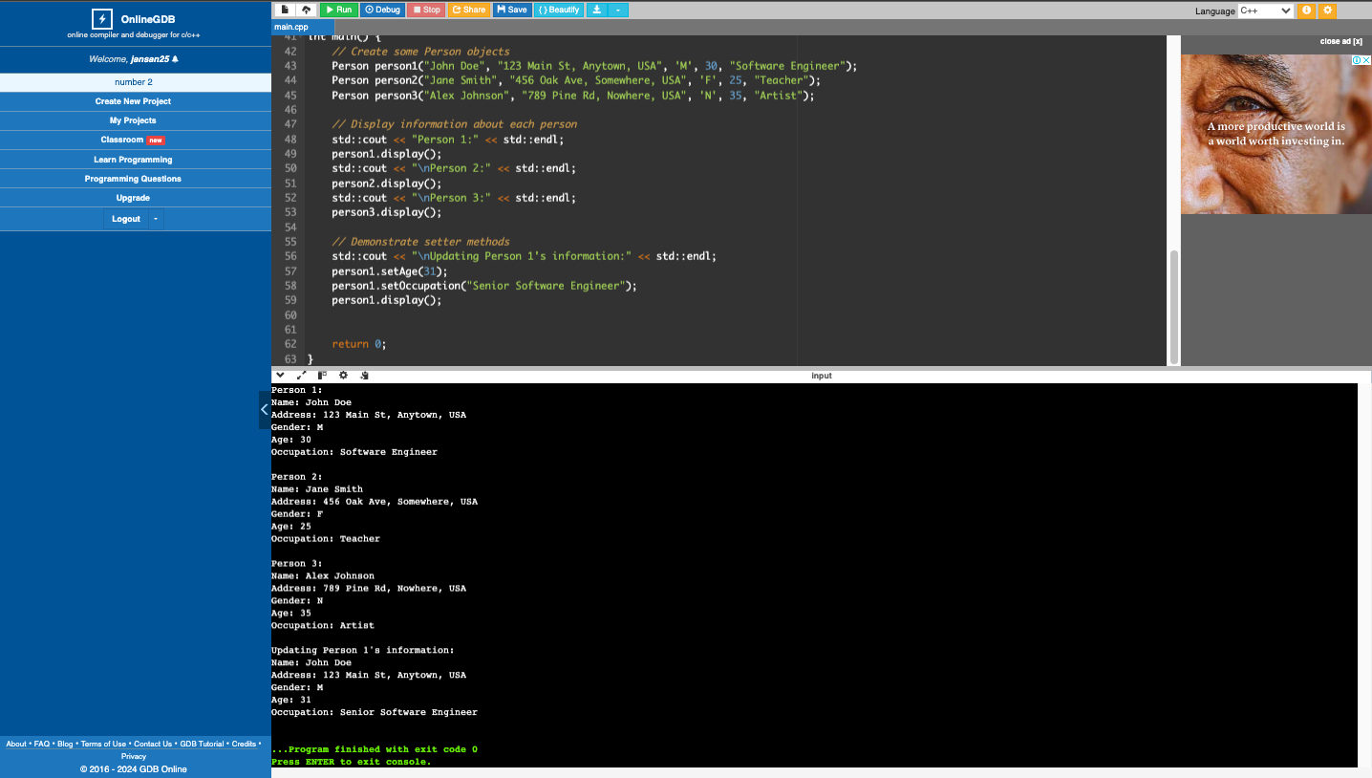

1. Write a class that will represent Polygon. Consider the name, number of sides and color.

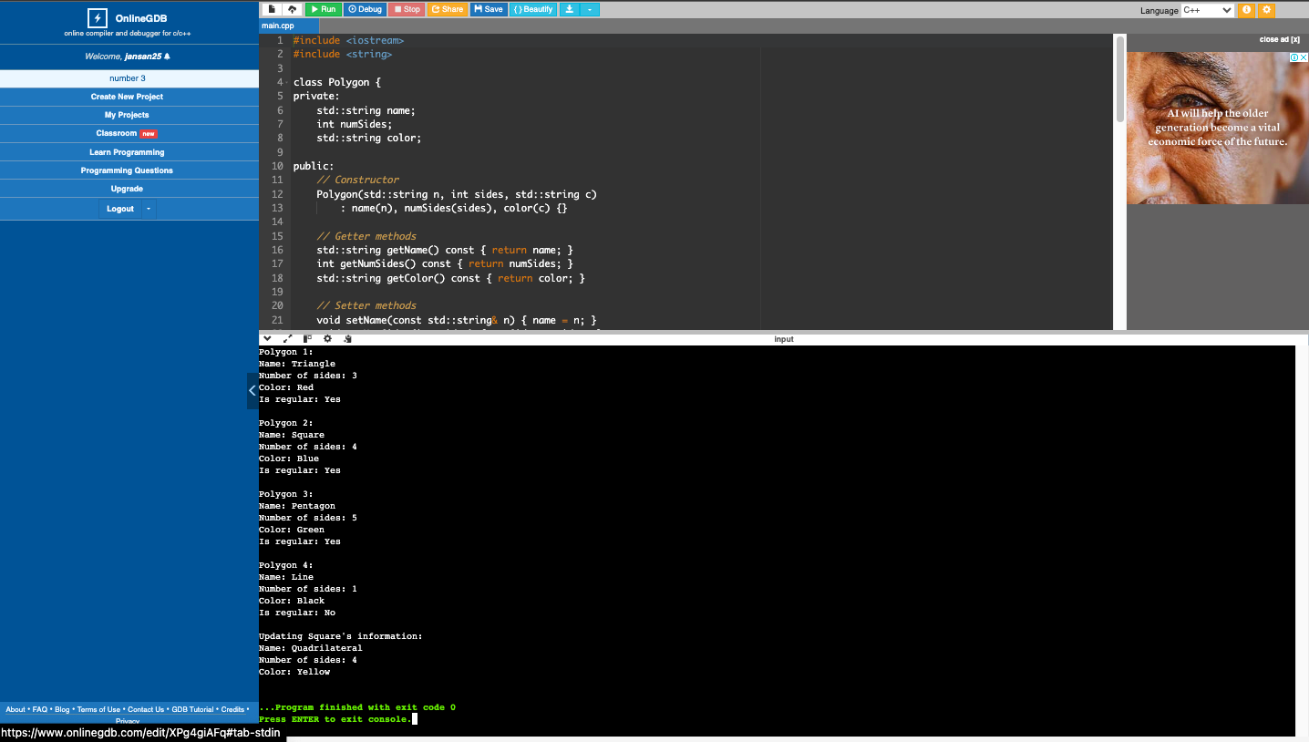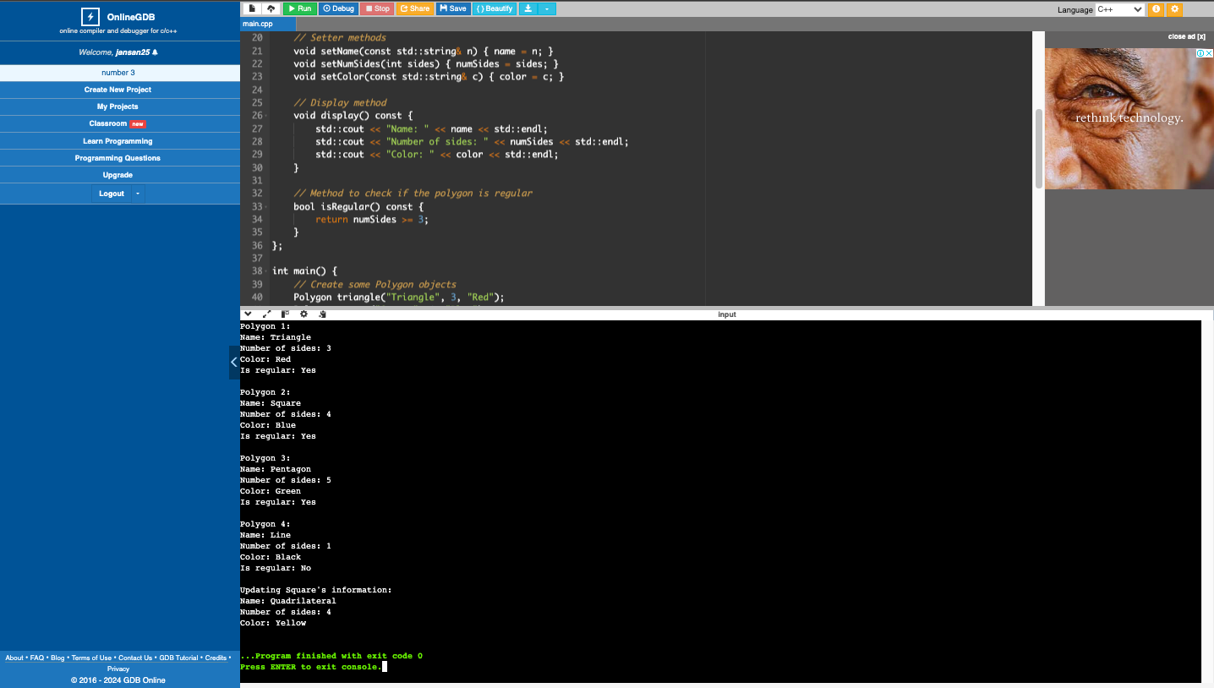

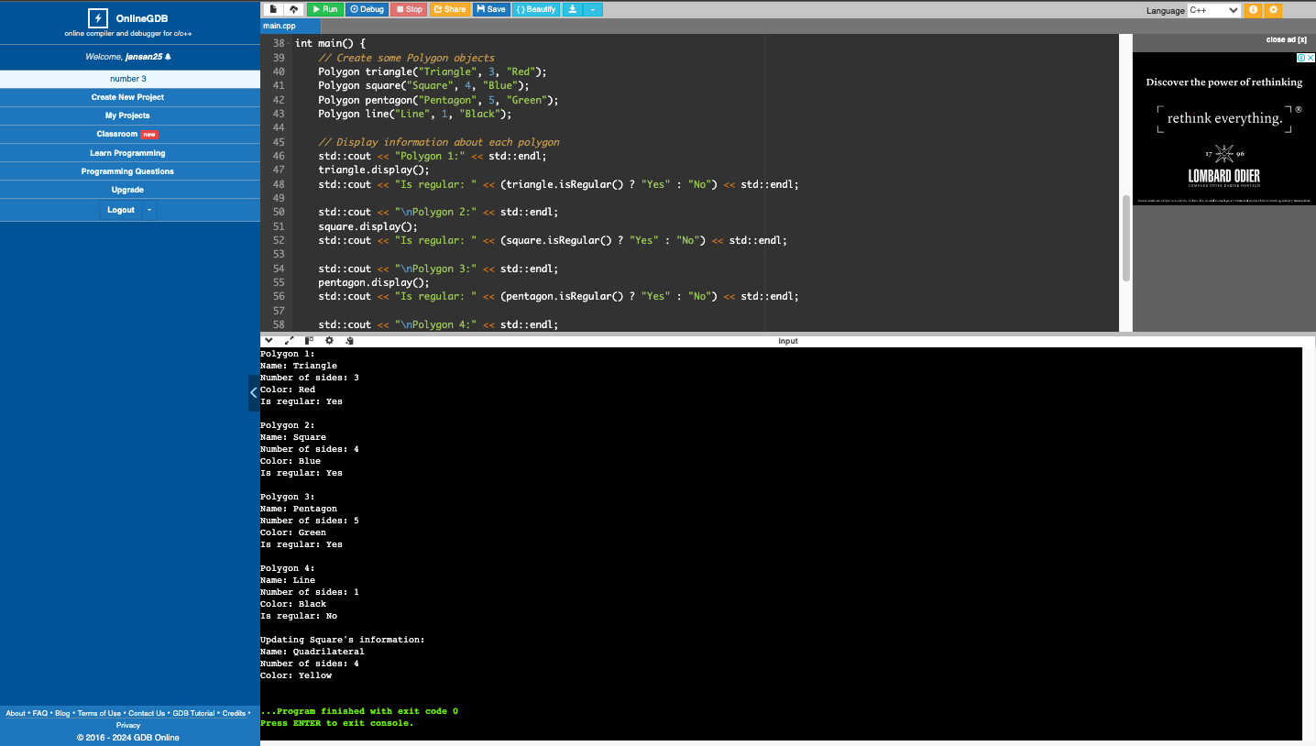

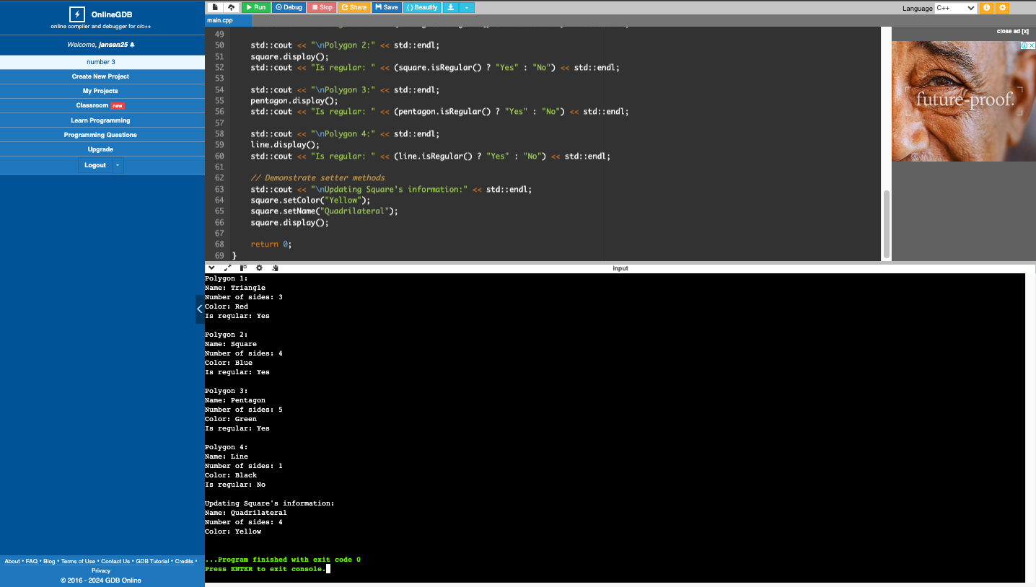

1. What can you conclude from this activity?

Object-Oriented Programming in C++ demonstrates the practical application of programming concepts, bridging the gap between code and real-world scenarios, and providing a powerful framework for modeling complex systems.